August
2023
Sunday | Monday | Tuesday | Wednesday | Thursday | Friday | Saturday
 |  | 1 | 2 | 3 | 4 | 5
6 | 7 | 8 | 9 | 10 | 11 | 12
 |  |  | First Day of School!
13 | 14 | 15 | 16 | 17 | 18 | 19
 |  |  |  | Choir Parent Meeting via Zoom @ 6:00pm
20 | 21 | 22 | 23 | 24 | 25 | 26
27 | 28 | 29 | 30 | 31
 |  |  |  | Money for Altitude Trampoline Park Due

September
2023
Sunday | Monday | Tuesday | Wednesday | Thursday | Friday | Saturday
 |  |  |  |  | 1 | 2
3 | 4 | 5 | 6 | 7 | 8 | 9
 |  |  |  | Choir Social @ Altitude Trampoline Park @ 5:00-7:00pm
10 | 11 | 12 | 13 | 14 | 15 | 16
 |  |  |  |  |  | 
17 | 18 | 19 | 20 | 21 | 22 | 23
 |  |  |  | JV & V Performance @ The Village at Sugar Land @ 10:30am-2:00pm
24 | 25 | 26 | 27 | 28 | 29 | 30
 |  |  |  | Beginners Rehearsal for Concert @ JBMS @ 4:15-5:00pm | No School!
October
2023
Sunday | Monday | Tuesday | Wednesday | Thursday | Friday | Saturday
1 | 2 | 3 | 4 | 5 | 6 | 7
 |  | Fall Concert – Beginners @ JBMS @5:15-6:45pm  2 Major Grades |  | Fall Concert – JV & V @ THS @5:15-6:45pm  2 Major Grades
8 | 9 | 10 | 11 | 12 | 13 | 14
 |  | No School!
15 | 16 | 17 | 18 | 19 | 20 | 21
 |  |  |  | Solo & Ensemble Mock Run-Through @ JBMS @4:15-5:15pm |  | Solo & Ensemble @ Sugar Land MS
22 | 23 | 24 | 25 | 26 | 27 | 28
 |  |  |  | Halloween Social @ JBMS @5:30-7:00pm
29 | 30 | 31
 |  | 
November
2023
Sunday | Monday | Tuesday | Wednesday | Thursday | Friday | Saturday
 |  |  | 1 | 2 | 3 | 4
 |  |  |  | 
5 | 6 | 7 | 8 | 9 | 10 | 11
 |  | Girls Night Social @ JBMS @ 4:15-5:15pm | Guys Night Social @ JBMS @ 4:15-5:15pm |  | No School! | 
12 | 13 | 14 | 15 | 16 | 17 | 18
 |  |  |  | Men’s Choir Festival @ Austin HS
19 | 20 | 21 | 22 | 23 | 24 | 25
Happy Thanksgiving! |  |  |  |  | 
26 | 27 | 28 | 29 | 30
December
2023
Sunday | Monday | Tuesday | Wednesday | Thursday | Friday | Saturday
 |  |  |  |  | 1 | 2
 |  |  |  |  | Winter Tour & Caroling @ Elementary Schools
3 | 4 | 5 | 6 | 7 | 8 | 9
 |  | Winter Concert – Beginners @ JBMS @ 5:15-7:00pm  2 Major Grades |  | Concert @ FBISD Admin Building & Sugar Land Town Square @ 11:00am-2:00pm | 
10 | 11 | 12 | 13 | 14 | 15 | 16
Winter Concert – JV & V @ THS @ 5:15-7:00pm
2 Major Grades
17 | 18 | 19 | 20 | 21 | 22 | 23
 | Happy Holidays! |  |  | 
24 | 25 | 26 | 27 | 28 | 29 | 30
 |  |  |  |  | 
31
January
2024
Sunday | Monday | Tuesday | Wednesday | Thursday | Friday | Saturday
 | 1 | 2 | 3 | 4 | 5 | 6
 |  | No School! | No School! | First Day of 2nd Semester!
7 | 8 | 9 | 10 | 11 | 12 | 13
 |  | Social w/ HS – Scavenger Hunt @ THS @ 4:15pm |  | 5th Grade Preview Night
14 | 15 | 16 | 17 | 18 | 19 | 20
 |  |  |  |  | Elementary Recruitment Tour
21 | 22 | 23 | 24 | 25 | 26 | 27
 |  | Money for Opera Trip Due  Girls Night @ JBMS @ 4:15-5:15pm |  | Guys Night @ JBMS @ 4:15-5:15pm
28 | 29 | 30 | 31
 |  | Opera Trip for Beginners @ 9:00am-2:00pm
February
2024
Sunday | Monday | Tuesday | Wednesday | Thursday | Friday | Saturday
 |  |  |  | 1 | 2 | 3
 |  |  |  |  | 
4 | 5 | 6 | 7 | 8 | 9 | 10
 |  | Beginner’s Performance @ The Village at Sugar Land @ 10:30am-2:00pm |  |  |  | 
11 | 12 | 13 | 14 | 15 | 16 | 17
 | Varsity Girls Rehearsal @ JBMS @ 4:15-5:15pm | Varsity Boys Rehearsal @ JBMS @ 4:15-5:15pm | JV Girls Rehearsal @ JBMS @ 4:15-5:15pm | Staff Luncheon by JBMS Fine Arts?  JV Boys Rehearsal @ JBMS @ 4:15-5:15pm | No School!
18 | 19 | 20 | 21 | 22 | 23 | 24
 |  |  | Pre-UIL Concert & SR Evaluation @ Sugar Land Methodist Church  Major Grade | Pre-UIL Concert & SR Evaluation @ Sugar Land Methodist Church  Major Grade
25 | 26 | 27 | 28 | 29
 |  | Preview Concert – Beginners @ JBMS @ 5:15-6:45pm  2 Major Grades |  | Pre-UIL Concert – JV & V @ THS @ 5:15-6:45pm  2 Major Grades
March
2024
Sunday | Monday | Tuesday | Wednesday | Thursday | Friday | Saturday
 |  |  |  |  | 1 | 2
 |  |  |  |  | No School!
3 | 4 | 5 | 6 | 7 | 8 | 9
 |  | UIL Concert & SR Evaluation @ Sugar Land Methodist Church  Major Grade | UIL Concert & SR Evaluation @ Sugar Land Methodist Church  Major Grade | UIL Concert & SR Evaluation @ Sugar Land Methodist Church  Major Grade
10 | 11 | 12 | 13 | 14 | 15 | 16
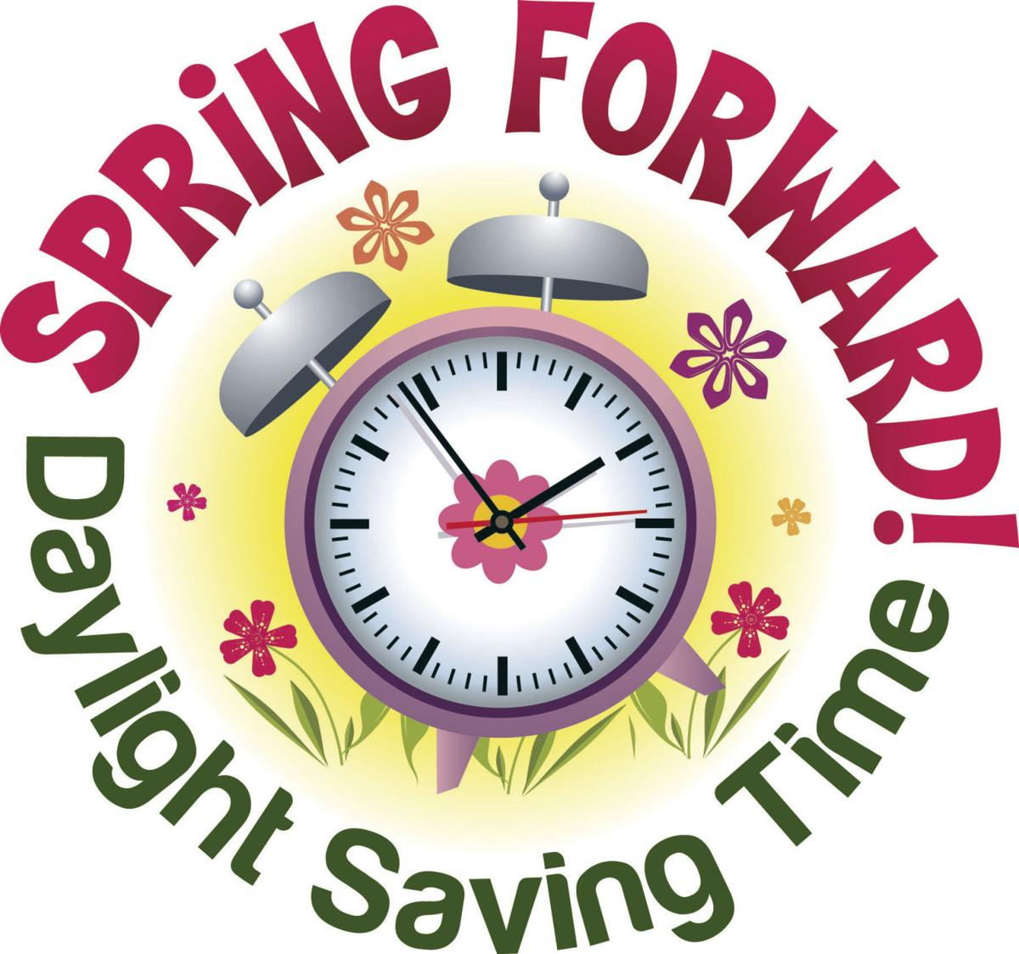 |  |  |  |  |  | 
17 | 18 | 19 | 20 | 21 | 22 | 23
 |  |  |  | Money for Main Event Due
24 | 25 | 26 | 27 | 28 | 29 | 30
 |  | SNV 7-8 Girls Rehearsal @ JBMS @ 4:15-5:00pm | SNV 7-8 Boys Rehearsal @ JBMS @ 4:15-5:00pm | Choir Social @ Main Event Stafford @ 5:00-7:00pm | 
31

April
2024
Sunday | Monday | Tuesday | Wednesday | Thursday | Friday | Saturday
 | 1 | 2 | 3 | 4 | 5 | 6
 |  |  |  |  | Shadow Creek Choral Festival @ Shadow Creek HS  Major Grade
7 | 8 | 9 | 10 | 11 | 12 | 13
14 | 15 | 16 | 17 | 18 | 19 | 20
 | 
21 | 22 | 23 | 24 | 25 | 26 | 27
 | 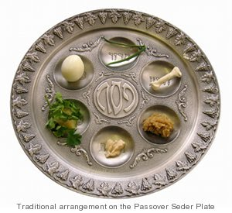 |  |  | Region Rehearsals @ JBMS @ 4:15-5:00pm | Region Rehearsals @ JBMS @ 4:15-5:00pm  Ice Cream Social | Region Auditions @ Sartartia MS  Major Grade
28 | 29 | 30
 |  | 6th Grade Rehearsal @ JBMS @ 4:15-5:00pm
May
2024
Sunday | Monday | Tuesday | Wednesday | Thursday | Friday | Saturday
 |  |  | 1 | 2 | 3 | 4
6th Grade Festival @ Elkins HS
Major Grade
5 | 6 | 7 | 8 | 9 | 10 | 11
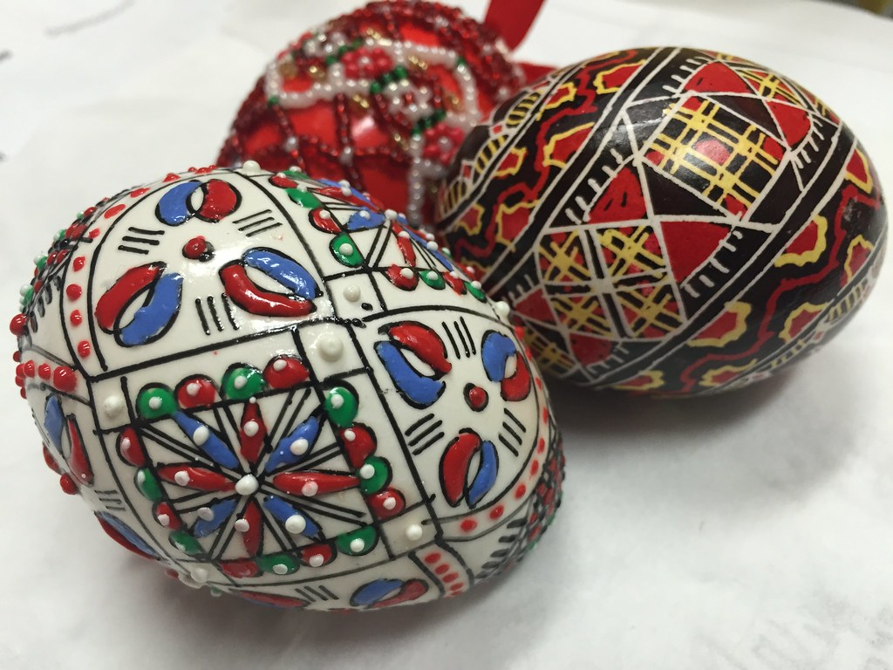 |  | Pop Show Dress Rehearsal @ JBMS @ 4:15-5:15pm |  | Pop Show Concert – All @ JBMS @ 5:15-7:00pm  2 Major Grades | Money for 8th Grade Choir Banquet Due | Region Clinic & Concert @ Crawford HS
12 | 13 | 14 | 15 | 16 | 17 | 18
 |  |  |  |  |  | Fine Arts Trip @ 6 Flags Fiesta Texas, San Antonio
19 | 20 | 21 | 22 | 23 | 24 | 25
 |  |  | Fine Arts Banquet – 8th Grade Only @ JBMS @ 6:00-7:00pm |  | Enjoy your Summer! | 
26 | 27 | 28 | 29 | 30 | 31
 | 

